Welcome!
Date
Name
Spouse
Address
City
State Zip _________
Email

Please Contact By
❑ Card  Phone  Visit

Telephone Best Time to Call
Home ______________
Work ______________

Guest: First Time Second Time
Are you a church member: yes no
Church
City, State

Circle Appropriate Age/Grade Group(s)
Preschool: Ages: B-1 2-3 4-5
Children: Grades: K 1 2 3 4 5 6
Youth: Grades: 7 8 9 10 11 12
Adults: Ages:18-29 30s 40s 50s 60s+

How did you learn about our church?
Newspaper Friend Yellow Pages Mail
Other

I am a guest of:

New in the Community? Yes No
Names & ages of children at home

Weekly Service & Activity Schedule

June 4, 2017
9:30 a.m. New Commandment Kids
9:45 a.m. Sunday School
11:00 a.m. Worship Service
“The Burden of Worry” Evening Video Series

Week of June 4, 2017
Wednesday 6:30 pm………………..…Meal/Bible Study
Thursday 10:00 am…………………..Adult Fellowship
Friday 6:30 pm……………..……………..Men’s 42 Night
June
11…………………………………New Commandment Kids
11…………………………………..……KSBC Homecoming
18………………………………………..……….Father’s Day
22……………………………………………Adult Fellowship
22…………………………………………..Stamp Card Class
25………………………………..…………Business Meeting

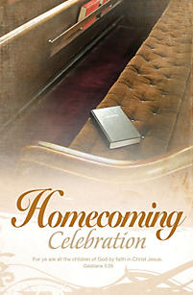
Knobbs Springs is celebrating 157 years of blessings!!

Join us for our annual Homecoming Celebration on June 11

Music, memories, and lunch on the grounds


VBS July 16-20
Anyone interested in volunteering contact Patti Radford



Knobbs Springs Baptist Church

June 4, 2017

Church Information:

KnobbsSpringsBC.com KnobbsSpringsBaptist@gmail.com

1662 CR 305, McDade, Texas 78650 512-273-2743

David Atwood, Pastor Cell 512-470-5098

Patti Radford, Office Manager Cell 512-968-7821

